Using Direct Simulation Monte Carlo(DSMC) To Model Gas Flow

Harsh Rathee

Department of Physics, University of California, Berkeley

Berkeley, CA 94720, USA

E-mail: harshrathee851@berkeley.edu

The direct simulation Monte Carlo (DSMC) method is a stochastic approach to solve the Boltzmann equation and is built on various numerical schemes for transport, collision and sampling. In this work, DSMC simulation has been used to study the flow of dilute gases in 2-D. The data obtained from the simulation has been used to study the dynamics of the system including velocity distribution of the particles, time evolution of particles under external forces like gravity, time evolution of particles of different masses when they are allowed to diffuse together and relationship of average kinetic energy of the particles with the temperature.

1. **Introduction**

DSMC is the Monte Carlo method for simulating dilute gas flow on molecular level. It is the basic method of simulation in kinetic theory of gases and rarefied gas dynamics. Kinetic theory of gases is a statistical approach to study the flow of gases at a molecular level and the flow is described in terms of change of probabilities of various states of gas molecules in space and in time.

DSMC is used to study the flow of dilute gas. Dilute gas is defined where the density parameter is small.

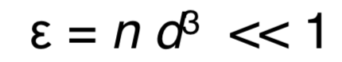

n is the numerical concentration of gas molecules

d is the diameter of the gas molecule

The air in Earth’s atmosphere can be considered as a dilute gas at almost any altitude. Thus, DSMC can be accurately used to study gas flow on Earth. Restraining ourselves to the regime of dilute gas allows us to make certain assumptions about the flow of gas like:

* Collision length scale is much smaller than the average distance between the molecules as a result of which most of the time, particles move without interactions with each other and collisions can be regarded as instantaneous change in velocities. Also, the motion of the particles can be divided into two parts: - collision less motion and instantaneous collisions.
* If Pn is the probability of simultaneous interactions between N gas molecules, then Pn+1 /Pn is proportional to the density parameter. Thus, only binary collisions between gas molecules are important.

There are various applications of DSMC including studying flows in upper space and vacuum, dynamics of upper planetary atmospheres, atmospheres of small bodies and study of non-equilibrium gas flows among many others. In this work, just the basics of dynamics of the flow of gases is studied to establish and test DSMC as a method for studying gas flows in 2-D. The data obtained from the simulations has been used to study the velocity distributions and time evolution of non-equilibrium systems.

1. **Methodology and Procedure**

The gas is represented by a set of N simulated molecules with each molecule being represented by its velocity and position.

The initial distribution of the positions is a uniform distribution but the distribution of velocities can be uniform or Maxwellian given by:

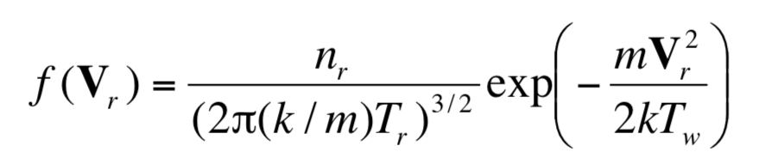

The velocities can be calculated using Box-Muller transform using random numbers.

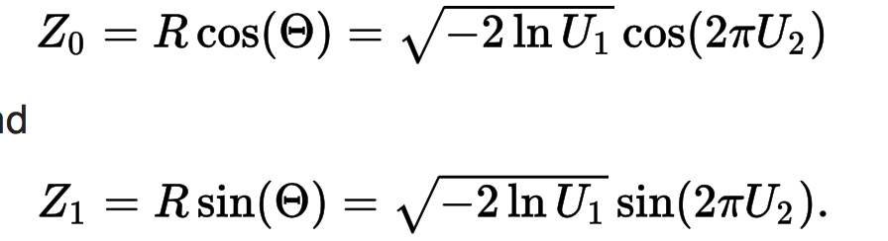

Then for each molecule, the gas flow is simulated as a change of the positions and velocities of the molecules in time due to:

* Free motion of particles or motion of particles under external forces like gravity
* Pair interactions(collisions) between gas molecules
* Interactions of molecules with surfaces or boundaries eg. walls

The free motion of particles or their motion under external forces is just studied by solving differentia equations for velocity and position in x and y directions for each time step. The method used for solving the differential equations is first order Euler Method.

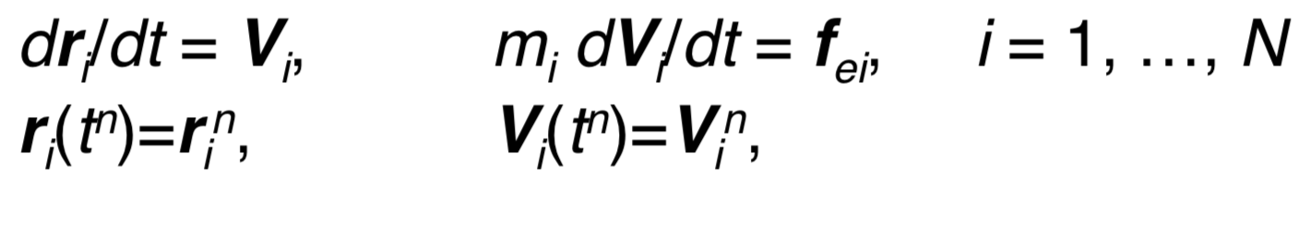

For simulating the collisions, the computational domain is divided into cells. In this simulation, the domain has been divided in to 50*50 cells. The number of collisions between molecules is defined by collision frequency v = /Users/harshrathee/Desktop/Screen Shot 2017-12-08 at 11.17.21 PM.png

Where g = relative velocity of particles

n = number density of particles

/Users/harshrathee/Desktop/Screen Shot 2017-12-08 at 11.17.21 PM.png = Cross section of molecules

Every simulated molecule in DSMC represents n molecules of real gas, where W = n/nSim is the statistical weight of a simulated molecule. In order to make the flow of simulated particles the same as flow of real gas, the cross-section of simulated molecules is calculated as follows:

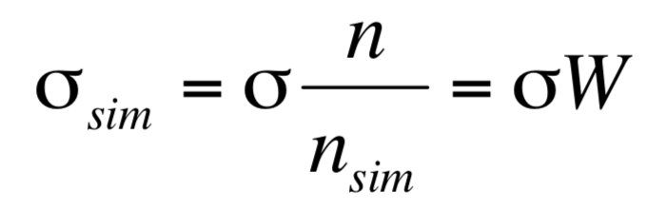

For each molecule, the index of the cell it belongs to is calculated and at any time step, only the collisions between molecules belonging to the same cell are taken into account. Every collision is regarded as a random event occurring with a probability of collision calculated by:

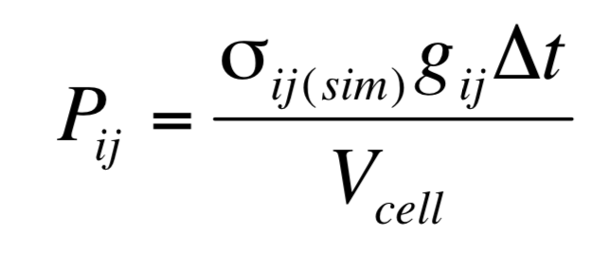

In each cell, pairs of randomly colliding molecules are sampled and the pre-collisional velocities are replaced with post-collisional velocities given by

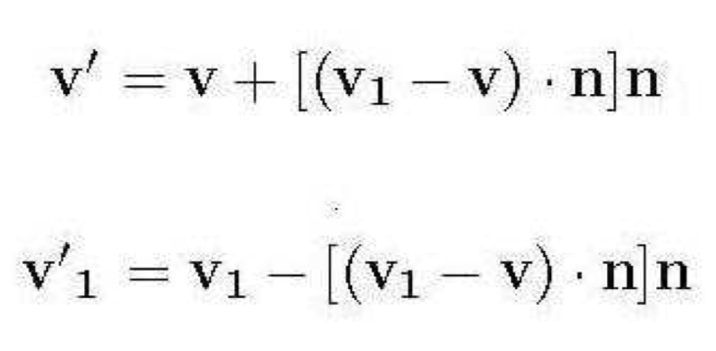

Where unit vector is the line of contact and is an isotropic homogenous vector and can be calculated using random numbers.



The sampling of bouncing from the boundaries can be simulated using two ways:

* By representing just the normal stress and thus an elastic collision
* Or by replacing velocities of reflected particles by a Maxwellian distribution to simulate heat flux. This again, is calculated using the Box-Muller Transform.

1. **Results**

First the particles were concentrated in a small part of the computer domain and allowed to evolve in time under gravity and random collisions. The final distribution of the particles in x and y directions was studied after half a second in real life. Also, the final velocity distributions of the particles were studied given that the initial velocity distribution was uniform in x and y directions.

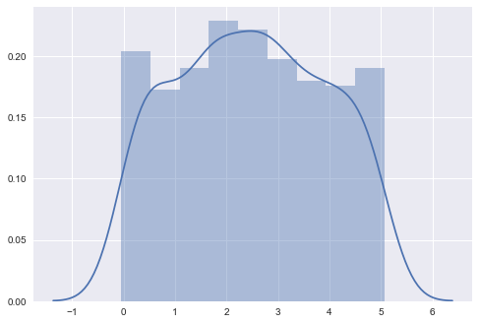

Figure 1

Final Distribution of particles in x direction.

As expected, it is uniform in x-direction.

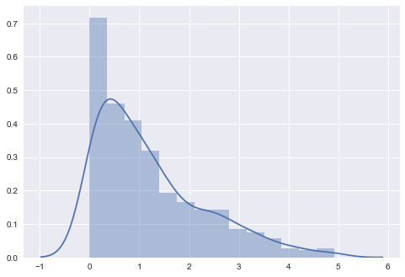

Figure 2

Final Distribution of particles in y direction under gravity.

As expected, it decays exponentially as expected by Boltzmann factor.

Thus, it can be seen that the particles automatically collect near the bottom and the number density decays exponentially as we go up. Here, it collision at the walls has not been modeled as an elastic collision, rather the walls absorb and dissipate energy such that the velocity distributions of the particles after the collision has the probability distribution in agreement with the canonical ensemble at a given Temperature.

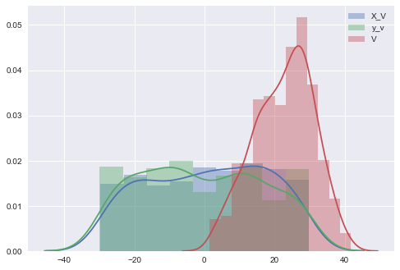

Figure 2

Initial velocity distribution.

It is uniform in x and y directions

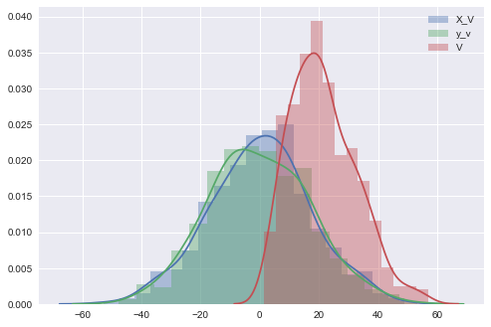

Figure 3

The final velocity distribution.

The velocity distribution is as predicted by the Maxwell-Boltzmann

Curve

Thus, the velocities arrange themselves according to the Maxwell-Boltzmann distribution automatically given random collisions between them.

Then the time evolution of particles of different masses was studied when they were allowed to diffuse together.

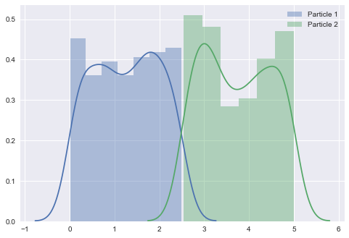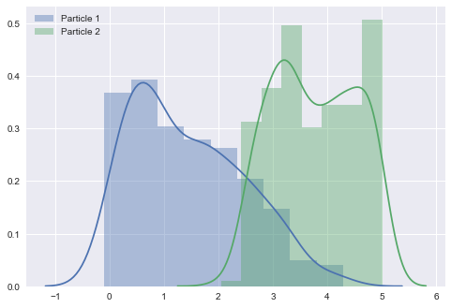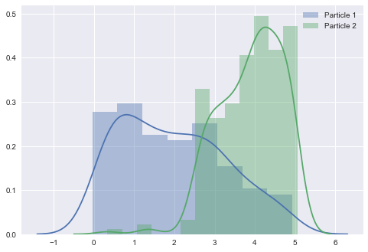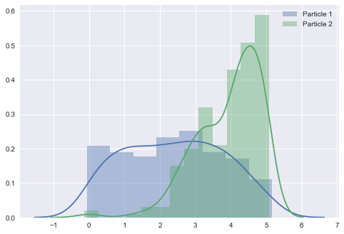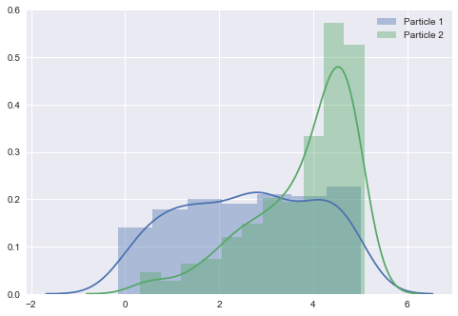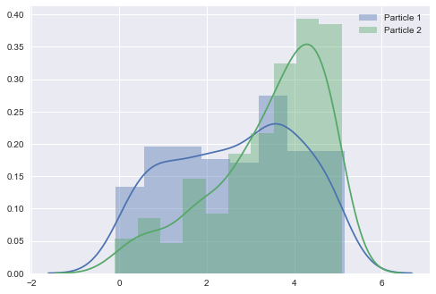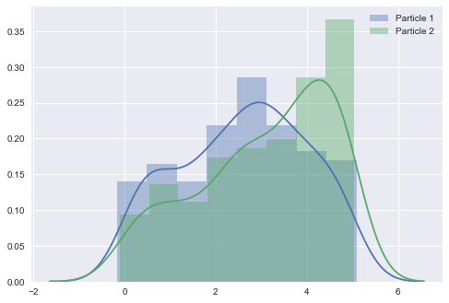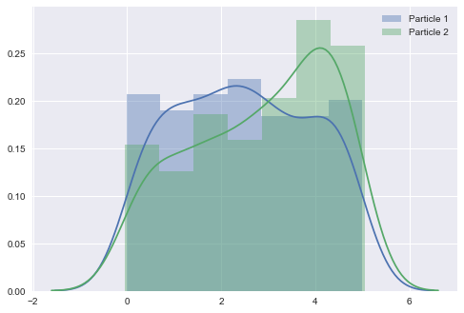

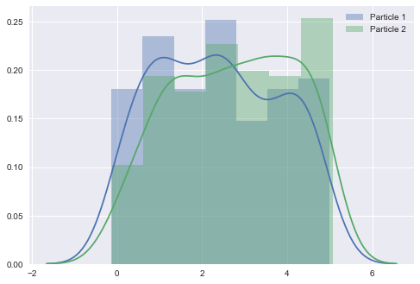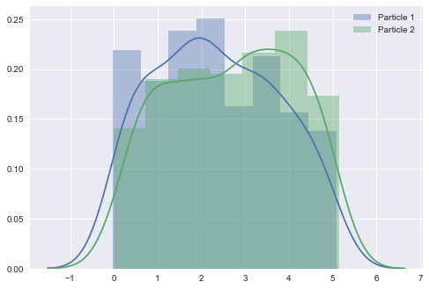

Figure 4

Time evolution in number density of particles in x-direction

as they diffuse

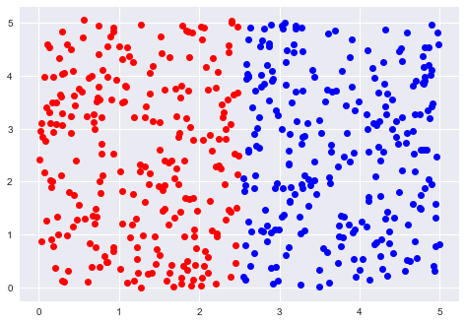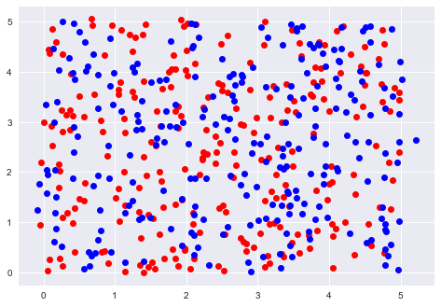

Figure 5

Start and End images of gaseous particles of different masses

Diffusing together

Particle 2 is about a 1000 times heavier than particle one and it can be seen from the diffusion graphs that the lighter particle diffuses faster than the heavier particle.

1. **Conclusion:**

A system of dilute gas particles has been simulated using the Technique – DSMC. The data obtained from the simulation has been used to study the dynamics of the system including velocity distribution of the particles, time evolution of particles under external forces like gravity, time evolution of particles of different masses when they are allowed to diffuse together and relationship of average kinetic energy of the particles with the temperature. The results have been consistent with theoretical predictions. There are many other properties of the system that can be studied using this like, pressure of particles on walls and diffusion under different geometrical constrains.

1. **Acknowledgement**

<http://people.virginia.edu/~lz2n/mse627/notes/DSMC.pdf>

http://docs.lib.purdue.edu/cgi/viewcontent.cgi?article=1044&context=aaepubs